Exploring Trends in American Baby Names
Before you proceed, consider the assumption that a name is considered "Classic" if it appears in 50 or more years, and "Trendy" otherwise.
- List the first five names in alphabetical order and find out if each name is "Classic" or "Trendy." Save your query as a DataFrame name_types with three columns: first_name, sum, and popularity_type.
- What were the top 20 male names overall, and how did the name Paul rank? Save your query as a DataFrame top_20 with three columns: name_rank, first_name, and sum.
- Which female names appeared in both 1920 and 2020? Save your query as a DataFrame a_names with two columns: first_name, and total_occurrences.
Note: Creating new cells in the workbook will rename the DataFrame. Make sure your solutions use the correct name:
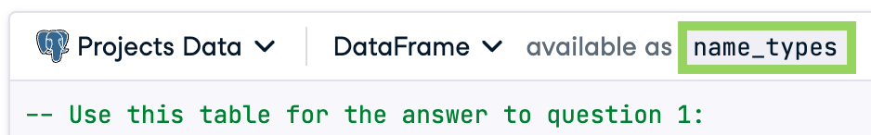

How have American baby name tastes changed since 1920? Which names have remained popular for over 100 years, and how do those names compare to more recent top baby names? These are considerations for many new parents, but the skills you'll practice while answering these queries are broadly applicable. After all, understanding trends and popularity is important for many businesses, too! You'll be working with data provided by the United States Social Security Administration, which lists first names along with the number and sex of babies they were given to in each year. For processing speed purposes, the dataset is limited to first names which were given to over 5,000 American babies in a given year. The data spans 101 years, from 1920 through 2020.
# `baby_names`
| column | type | description
| `year` | int | year
| `first_name` | varchar | first name
| `sex` | varchar | `sex` of babies given `first_name`
| `num` | int | number of babies of `sex` given `first_name` in that `year`

Q1. List the overall top five names in alphabetical order and find out if each name is "Classic" or "Trendy."
Q2. What were the top 20 male names overall, and how did the name Paul rank?
Q3. Which female names appeared in both 1920 and 2020?

Answers:
Q1. List the overall top five names in alphabetical order and find out if each name is "Classic" or "Trendy."
SELECT first_name, SUM(num),
CASE WHEN SUM(num) > 50 THEN 'Classic' ELSE 'Trendy' END AS popularity_type
FROM baby_names
GROUP BY first_name
ORDER BY first_name
LIMIT 5;

Q2. What were the top 20 male names overall, and how did the name Paul rank?

SELECT DENSE_RANK() OVER (ORDER BY SUM(num) DESC) AS name_rank,
first_name, SUM(num)
FROM baby_names
WHERE sex = 'M'
GROUP BY first_name
ORDER BY SUM(num) DESC, first_name
LIMIT 20;

Q3. Which female names appeared in both 1920 and 2020?

SELECT first_name,
COUNT(*) AS total_occurrences
FROM baby_names
WHERE sex = 'F'
AND year = 1920
GROUP BY first_name

INTERSECT

SELECT first_name,
COUNT(*) AS total_occurrences
FROM baby_names
WHERE sex = 'F'
AND year = 2020
GROUP BY first_name

ORDER BY total_occurrences DESC;

